|  |  |
| --- | --- |
| *Name* | *Lamps* |
| *Color* | ***White*** |
| *Size* | ***1feet*** |
| *Brand* | ***Philips*** |
| *Price* | ***PKR 300*** |

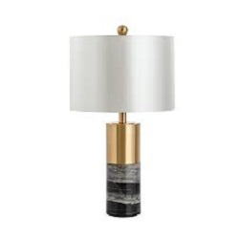

|  |  |
| --- | --- |
| *Name* | *Lamps* |
| *Color* | ***White*** |
| *Size* | ***1feet*** |
| *Brand* | ***Philips*** |
| *Price* | ***PKR 350*** |

|  |  |
| --- | --- |
| *Name* | *Lamps* |
| *Color* | ***White*** |
| *Size* | ***1feet*** |
| *Brand* | ***Philips*** |
| *Price* | ***PKR 350*** |

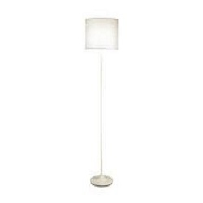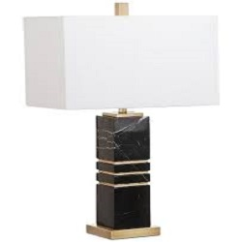

|  |  |
| --- | --- |
| *Name* | *Lamps* |
| *Color* | ***Black*** |
| *Size* | ***1feet*** |
| *Brand* | ***Philips*** |
| *Price* | ***PKR 350*** |

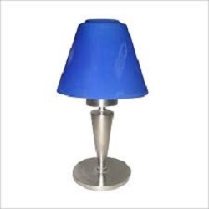

|  |  |
| --- | --- |
| *Name* | *Lamps* |
| *Color* | ***Blue*** |
| *Size* | ***1feet*** |
| *Brand* | ***Philips*** |
| *Price* | ***PKR 3500*** |

|  |  |
| --- | --- |
| *Name* | *Lamps* |
| *Color* | ***Dark Grey*** |
| *Size* | ***1feet*** |
| *Brand* | ***Philips*** |
| *Price* | ***PKR 350*** |

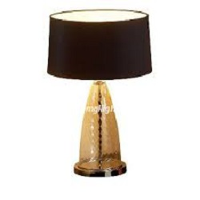

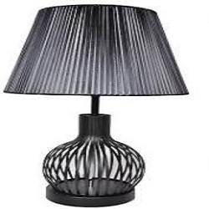

|  |  |
| --- | --- |
| *Name* | *Lamps* |
| *Color* | ***White*** |
| *Size* | ***1feet*** |
| *Brand* | ***Philips*** |
| *Price* | ***PKR 350*** |

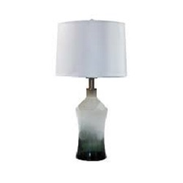

|  |  |
| --- | --- |
| *Name* | *Lamps* |
| *Color* | ***Light Brown*** |
| *Size* | ***1feet*** |
| *Brand* | ***Philips*** |
| *Price* | ***PKR 350*** |

|  |  |
| --- | --- |
| *Name* | *Lamps* |
| *Color* | ***White*** |
| *Size* | ***1feet*** |
| *Brand* | ***Philips*** |
| *Price* | ***PKR 350*** |

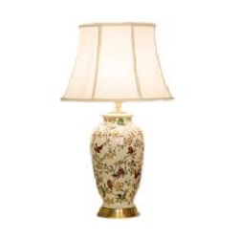

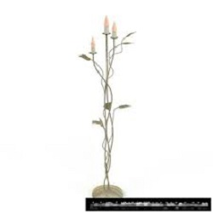

|  |  |
| --- | --- |
| *Name* | *Lamps* |
| *Color* | ***White*** |
| *Size* | ***1feet*** |
| *Brand* | ***Philips*** |
| *Price* | ***PKR 350*** |

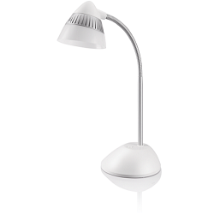

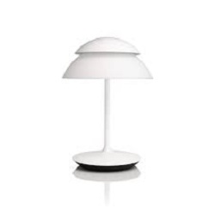

|  |  |
| --- | --- |
| *Name* | *Lamps* |
| *Color* | ***White*** |
| *Size* | ***1feet*** |
| *Brand* | ***Philips*** |
| *Price* | ***PKR 350*** |

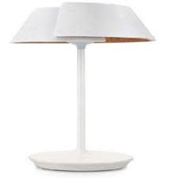

|  |  |
| --- | --- |
| *Name* | *Lamps* |
| *Color* | ***White*** |
| *Size* | ***1feet*** |
| *Brand* | ***Philips*** |
| *Price* | ***PKR 350*** |